# Chapter-1

# 1. Introduction

A website is a collection of pages that contains the subject materials or information. Hotel Booking Management System is web application system where people can easily book their rooms with their various options. This is web application where only support for browser system which is fast and easily control the system activities.

## 1.1 Background of system

Hotel Booking Management System have focused on reservation system where client should enter details with the help of internet connection. User also have options to choose book rooms like types of room, how many days you want to stay in hotel and what type of bed you want.

User can able to subscribe their newsletter for to get event notification about hotel. For this project, I have used Waterfall Model because it is step by step guide and it is also an individual project so this methodology aids to control project. XAMPP is used server for database system for storing user information to accessed anytime. Core PHP is a Programming Language for developing website.

## 1.2 Overview of system

In this system have two operator Admin and Client. User can able to book their room either login or guest system. If after logged into user dashboard there is options to apply CRUD operation. In Home page of this website have parallax effects which is unique and looks attractive. It aids clients to know about their services, user experiences at hotel. Basically, this system has focused on to save time and money comparison to another hotel.

## 1.3 Aims and Objectives

**Aims**

The main aims of this project are:

* It helps to improved customer satisfaction through online booking system,
* To reduce time and increase quality of services,
* To access these services through internet form anywhere,
* To maintain security in system for save information from hacker,

**Objectives**

The main objectives of this project are:

* It aids to decrease manual paper work,
* It aids to maintain accuracy to minimize errors,
* It helps to system user friendly interface which is flexible,
* To admin have permission to add, update and delete their hotel rooms,
* To admin can able to add new admin and delete admin,
* To store client data which can be easily accessed anytime from anywhere.

# Chapter-2

# 2. Analysis

## 2.1 Introduction

In first step of development stage, we need to collect all the information about problem in our project and find out the solution for that we need to do analysis. Analysis is the method or way of collecting data and comparing with the other information system. it helps to identify area of problem and provides solution of how to improve overall quality of that system. This analysis is based on user requirement, find out the issues and developing the product.

This is the most important stage while doing this project which aids to find out goals and purpose. In this analysis step, there are multiple ways like gathering information, identify problem and prototype developing based on this system. In this system, it will need to focus on user requirement rather than technical aspect. I am going to choose CATWOE Analysis which is known as soft approach methodology. Use case and class diagram are used for inexperience person. User requirement is easily show in diagram and that are easier to understand.

In this project, I am using PHP Language for developing the Hotel Booking Management System. This is browser-based web application focuses on user requirement to booked hotel room. This website user can book room and admin can insert, update and delete their hotel features.

In this project, there are some activities which are involved in analysis phase:

1. **Requirement Analysis**

In this stage, we need to find out the requirement analysis of the project and solve the problem with increasing better quality of website. The main purpose of this analysis is to find scope of this project and establish the user experience in our system.

1. **Hardware study**

This hardware study step, we need to find out whether or not,

* Hardware and software are required to execute this project,
* How much time it takes to response and process on it.

1. **System design requirement**

In this stage, the design which is help to describe our project interface. We need to discuss in design includes the logical, objects, database and coding of overall project work.

1. **System implementation**

In this stage, we discuss about core logic implementation part to write a program or code and we will be created database for storing user information.

1. **System Modification**

In this stage we discuss if we will have to change in something then we will change after a certain time based on user requirement and we need to change some requirement, add features or fixing errors then we modify on it.

We need to perform analysis because in development process, there is so many features or requirement need to implement. Analysis is the process of collecting the user requirement that we need to implement in this system. If there are some problem before starts design or coding on project, that helps to completely reduces issues. The main moto of analysis in our system is to increase productivity and enhance quality of work.

## 2.2 CATWOE Analysis

I decided to use CATWOE analysis methods for my project because it is the methods of find out the issues and processes. To develop Hotel booking management system user-friendly, the CATWOE analysis methods can able to identify people view because of it is soft approach methodology has focus on user perspectives. CATWOE is an ethical framework which helps to problem solving approach. It is the simplest and easiest method of checklist to find the solution of problems.

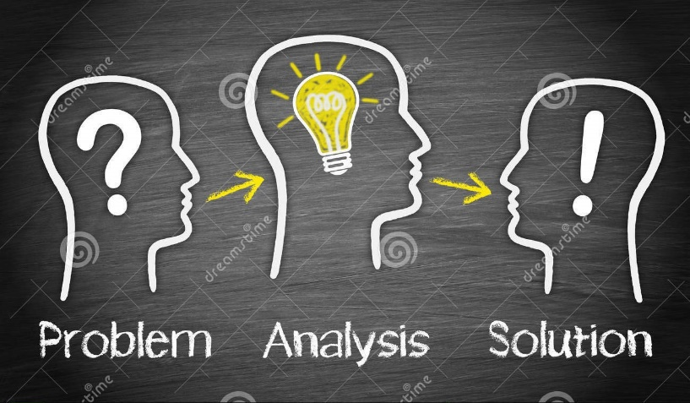

CATWOE analysis have six elements and have different analysis features are:

1. **Client/Customer-** In this project-based client/customer are user. Customer are the most important thing about this system. If customer is directly affected to this system. So, we will need to address immediately to avoid serious consequences.
2. **Actors-** The actor in that case are the employee or admin who controls that system. There is insider employee, admin and outsider are user. We need to find out the role of that actor in system.
3. **Transformations-** In this stage, it describes the process of input and output which is based on system process. We have carefully considered to this step is that, what the input requires and what the result will be.

1. **Worldview-** The worldview in this case is looking for, what problems that we are going to solving from that system. It describes that the problem is long lasting effect or short-term effect. It will help to handle all problems.
2. **Owner-** Owner in this case are admin or manager is the ownership can be able to handle the problem. This owner analysis helps to control the way in rectifying the task problem.
3. **Environment-** In the last step, we faced some environment issues like budget, legal issues are involved in project. Form beginning, we able to solving step by step to filtered problem. Then it helps to solve or clear the problem.

## 2.3 Feasibility Study

Feasibility study is an analysis the skill of developers and evaluate of this project. It is also called test of a system proposal based on its workability. If our project more reliable and user-friendly then we need to do feasibility study in our project. It helps to development save time, money, add new features based on user requirement. Feasibility study identify the valid reason to undertake this project, aids to increase decision making and provide alternative solution in project.

There are some common factors of feasibility study are:

1. **Technical Feasibility**

This study is the project idea that explored in detail to find out its technical feasibility. It evaluates the hardware and software are requirement of this project. If our project is technically feasible or pollution caused by this project. It is also called system feasibility. We will have to developed our project need eco-friendly.

1. **Economic Feasibility**

The economic feasibility is the analysis of cost and income determined based upon effort whether or not it is logical of this project. Basically, it helps to reduce and avoid cost and determine how much time to take in development in system.

1. **Schedule Feasibility**

This hotel booking management system has allocated time to complete task. Schedule feasibility helps to identify whether on not is completed in the available time.

1. **Operational Feasibility**

This stage helps to measure that our project will be able to solve that problem. If our project completely new then user feel comfortable or accepting of the change new system.

1. **Legal Feasibility**

It is the most important for study to know that our system is legal or not. Legal feasibility defines whether our system will fulfil the legal requirements or not. If there is no issue then user can easily communicate with on it.

## 2.4 Requirement analysis

It is the process of achieving the requirement what they want. It is the part of system development life cycle. In this stage, to determines that our system function and process would be comfortable to access a new system.

## 2.4.1 Functional Requirement

The functional requirement is that, the developers implement the software features and function according to user requirements. It also describes the behaviour of system based on the task conditions.

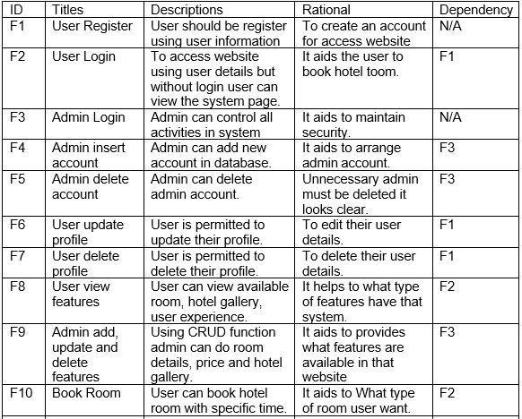

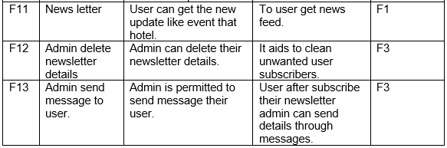

## 2.4.2 Non-Functional Requirement

This non-functional requirement describes that how this system project will do it. It is specifying the system quality of an attribute for a system.

There are some non-functional are listed below in tabular form:

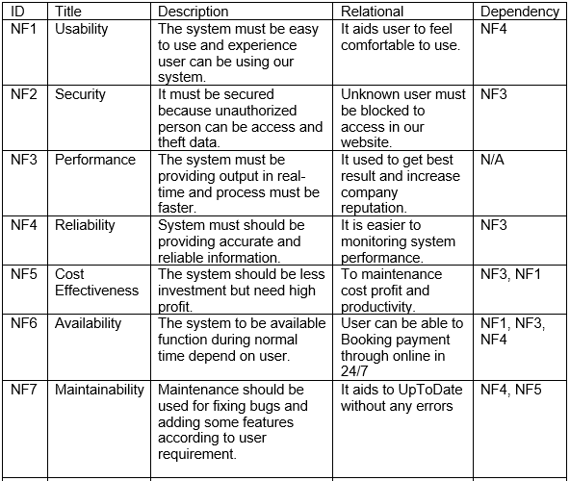

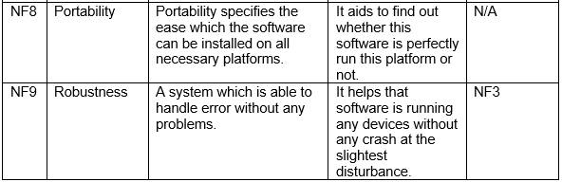

## 2.4.3 MoSCoW Prioritization

MoSCoW is the very important methods in project that develop easy and clear requirement of the user and their priority. This is step by step of gathering the user requirement with listed on it. Then all requirements are ranking with high to low priority topic and solved it. MoSCoW prioritization helps to provide security and increase performance of the system.

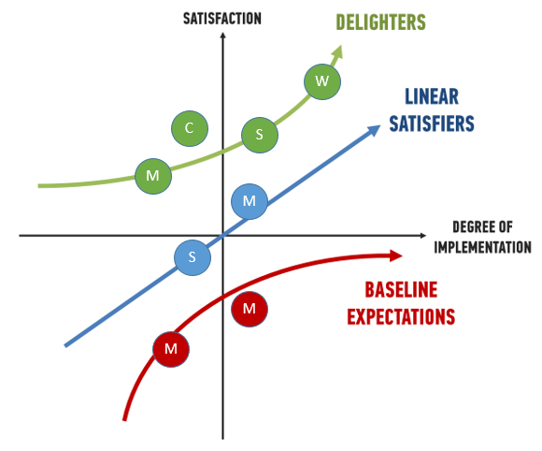

The MoSCoW prioritization stand for:

* **Must Have:** The requirement which is the most important for the system that must be involved.
* **Should Have:** Should have this requirement is high priority but not vital.
* **Could Have:** The requirement is that could be important but it doesn’t affect anything on this project.
* **Won’t Have:** The team members decided that, the requirement which delivery won’t be this time.

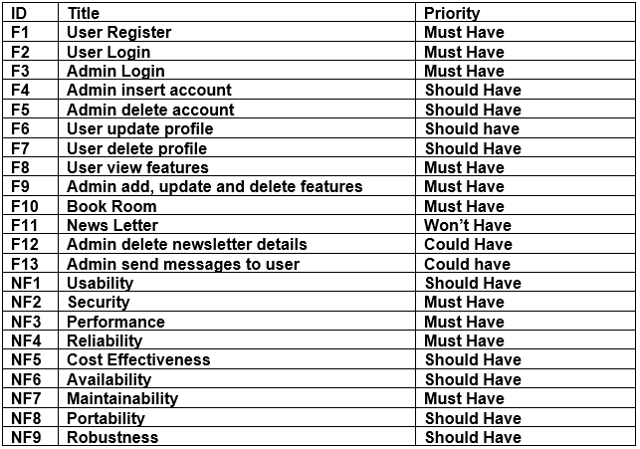

## 2.4.4 SRS (System Requirement Specification)

An SRS is system requirement specification for used in Hotel Booking Management System is web browser application-based project. It is used to gather all data, functional, behavioural requirement while developing this project. It describes the functionality of the system that need to be fulfil user requirement. Generally, it includes the system purpose, overall description and specification requirements. It aids to save time, money and increase confidentiality.

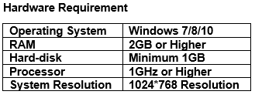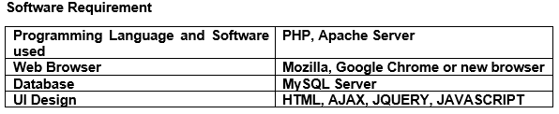

## 2.5 Use Case

A use case is the process or arranging and represent data with user requirement on diagram. It is a powerful technique of black box function requirement. It helps to identify the interaction between user and system process with clear points. Use case can aid to manage the hard and large project to divides in small points. A use case has illustrated using notation to connect to actor what roles are playing this project and showing what is happing in this system. In this hotel booking management system I have used StarUML for draw diagram. StarUML has many features that help us to draw simple and attractive diagram.

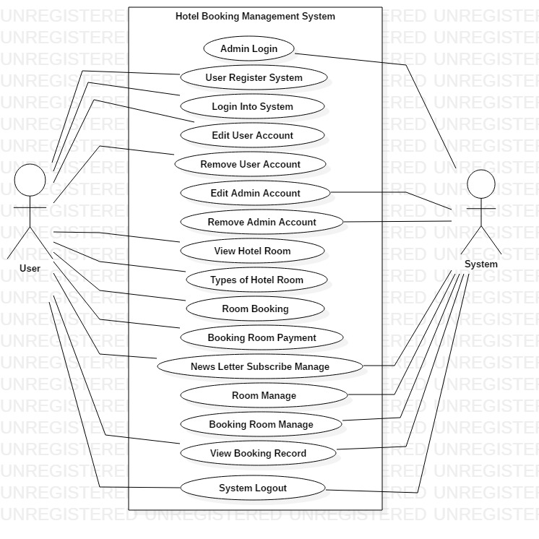

Figure 1:Hotel booking management system User case

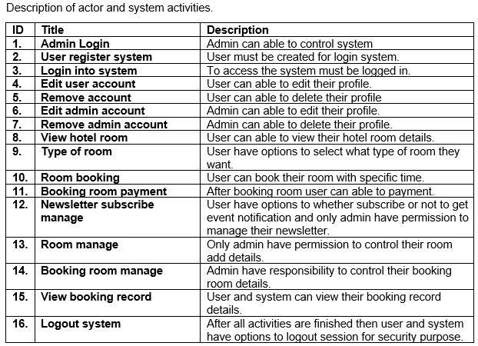

## 2.6 NLA (Natural Language Analysis)

NLA is Natural language analysis. It is the process of identify the noun, verbs and adjectives. It is the step by step analysis to gathering requirement form task. While doing the NLA process there are some step to follow the rules are:

* Find out the noun and verb,
* Removed double word form noun and verb,
* Removed synonymous noun and verb,
* Then we will get noun to candidate classes and verb to candidate operation.

**Class:** Simply, class is the blueprint of a group of objects that play the main role of the system contains with structure and behavioural features. Structure means static and behavioural means dynamic features of class.

**Attribute:** It is an object of property of class. It stores in second or below of class displayed in different line.

**Operation:** It is also called methods that store in third row or below of an attribute displayed in list format.

This project summery is:

Hotel Booking Management System is web browser-based application for user can easily booked hotel room. Firstly, to access this website user need to create account then login to the system. User can view website without login but not allowed to use the features. With login user can have allowed to add, edit and remove data as well as to view information. System have permission to used CRUD on their features like insert, update and delete their admin account.

After login user can be able to Booked room choice of what types of room they want with payment on specific price. In this hotel room have organized many events and offer on room booking system. For to get update the hotel events, user have choice to subscribe their newsletter and system should be managed it. Room manage, booking room manage and Bills generate by system. At last step user and system have options to logout from system.

## 2.7 Class Diagram

It is one of the most advance and easiest diagrams which shows the modelling relationship between class, attribute and operation with the objects. Class diagram also known as static diagram because this is not used for visualizing, describing but only used to executable code of the system.

Form above summery class, attribute and operation have allocated in below table:

|  |  |  |
| --- | --- | --- |
| **Noun (class)** | **Adjective (attribute)** | **Verbs (Operation)** |
| User, Room Booking, Contact, Admin, Payment System, Room | Browser-based, Able, Specific, Many, Last | Create, Add, Edit, Delete |

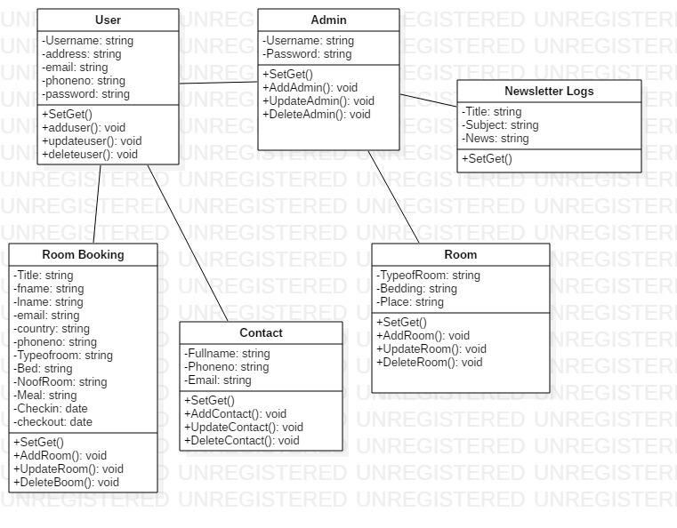

Figure 2:Hotel Booking Management System Class Diagram

# 2.8 Conclusion

Finally, at the last analysis for the Hotel Booking Management System have successfully listed out. In first step, we listed out all the activities that are involved in analysis. Then, we used CATWOY analysis for it is soft approach methodology which describe the user perspective rather than technical. Next step, we used feasibility study analysis for technical and user issues based on this project. Functional and non-Functional are prioritized based on MoSCoW prioritization method. In use case diagram represent the task between system and user. At the last, we design class diagram with their class, attribute and operations.

# Chapter-3

## 3.1 Design

In this design stage, a design is a plan or art or drawing of something before build or made. And design also known as blueprint. Generally, design provides the step by step action or function in any projects. Design is the most important phase for any application development which is directly or indirectly involved in this project. In design have three different methods and tools are structural model, behavioural model and database model.

In this hotel booking management system, we are using StarUML tools for create diagrams like use case, class diagram, activity diagram and sequence diagram. StarUML is open source application that helps to design function. It is also fast, many functionalities and feasible.

## 3.2 Structural Design

It is a tools and methods which we find out safe structure to carry the load. Structural model is also known as static structural that aids to show the relationship and properties. Example of structural design is class diagram Which is helps to describe the overview of this project.

### a) Class diagram

It is a static model which is describe the relationship between classes, attributes, objects and methods in same system class. Class diagram is easy to use, understanding the system views and clearly describe in diagram based on user requirement.

Class diagram is the most important stage in this project of design phase:

* It helps to describe the relationship between class and object,
* In hotel booking management system have describe the user and system relations,
* It describes the responsibilities of this system,
* Supportive for developer and other members too in system.

This diagram has different types of notation and components which is helps to combined the relation of each classes.

1. **Generalization**

It describes the relationship between two classes which has general and specific classes.



1. **Association**

It shows the two-class relationship with each other.



1. **Multiplicity**

The number of objects that are involved in an association

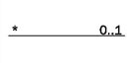

1. **Aggregation**

It controls the relationship between classes.

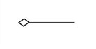

1. **Class**

Class describes the methods as well as its properties.

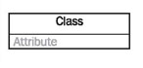

1. **Attribute**

Defined in second row in class shape displayed on separate line.

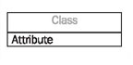

1. **Methods**

It defined in third row in class shape displayed on its own line.

This class diagram was drawn through user requirement which is collect thought analysis of this project that shown in below:



Figure 3:Hotel Booking Management System Class Diagram

From the above diagram showing hotel booking management system activities that happen between user and system admin. From above user can book hotel room and contact relations. Admin can control the cash payment system from user booking hotel room. admin can able to control room system.

### b) Data Flow Diagram

Data flow diagram is to visualize that how the data is processed or system that involves the transfer of data. It is a network representation of a system using the notation to describe the entities and their relationship.

In hotel booking management system DFD is also important in design phase are:

* DFD is the process which makes good communication between user and this system,
* It provides a graphical representation of how information flow between processes in a system,
* It is a logical information flow with clear and easily understanding of the system,
* Provide more detailed with breakout of piece of context level of diagram in system.

In Data Flow Diagram have three level which is clearly describes the system. There is some notation which is help to show relation:

1. Process

Function where the manipulation and transformation of data takes place. In process receives the input and change output in different form or content with represents in a rounded rectangle process.

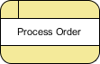

1. External Entity

It shows a human, system or subsystem data where comes from or goes to. It represents in rectangle an entity but do not process data to system.



1. Data store

A data which is used to hold information in storage and if data need for after certain time, it is easy to retrieve information. It indicates written data incoming arrow and read outgoing arrow.



1. Data Flow

A data flow indicates with the arrow with direction of the flow of information which is transfer one path of system information to another.

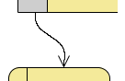

This system Diagram representation of Data Flow Diagram form level 0, level 1 and level 2 drawn in below:

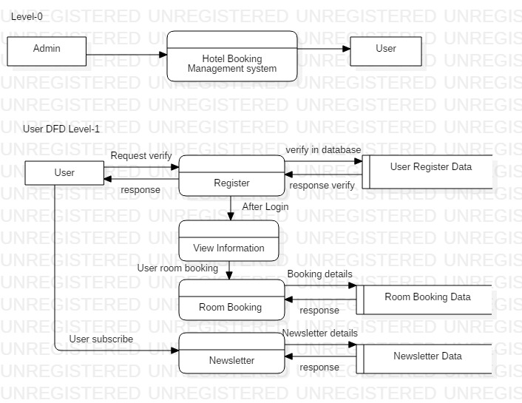

Figure 4:Data Flow Diagram of User Level-1

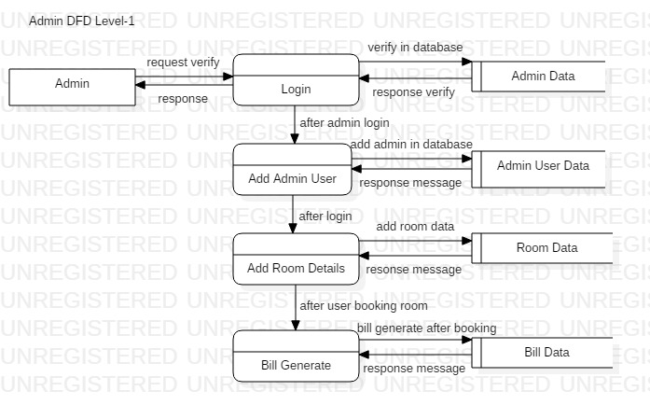

Figure 5:Data Flow Diagram of Admin Level-1

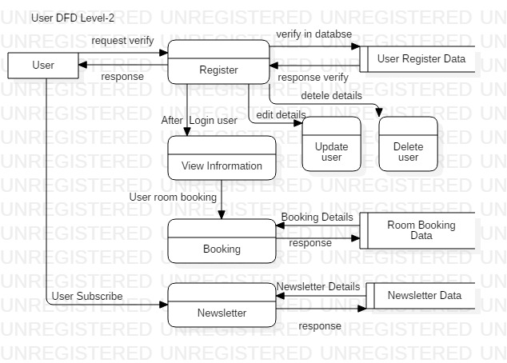

Figure 6:Data Flow Diagram of User Level-2

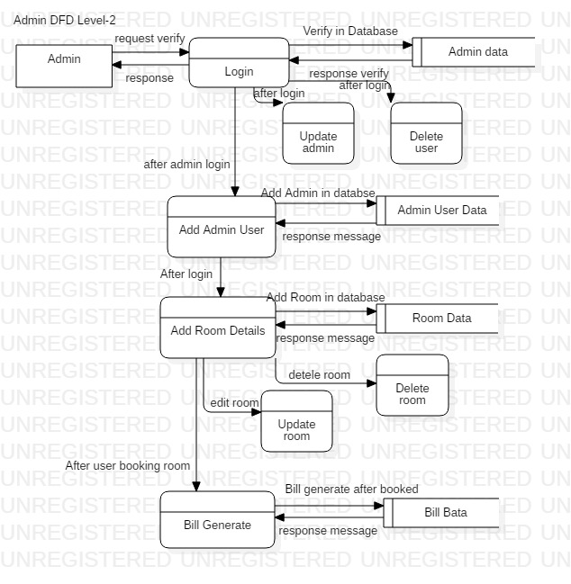

Figure 7:Data Flow Diagram of Admin Level-2

From above figure there are two actors which is interaction with the system. In DFD there are three level, which show the flow of activities in system. In level 0 there is only describe the admin and user discuss with our system. In level 1 describe the admin and user directly or indirectly process and communication with database. At last step of level 3, describe all the activity what happen from begins to ending points.

## 3.3 Behavioural Design

Behavioural design has also called dynamic design of system which is not change over the time. It deals with every type of behaviour in system. In hotel booking management system this design focus on how a structure of this system and as well as collect viewed by the user based on their user requirements. Its shows in architecture design form. Data processing and static machine mode are the two parts are included in it. Use-case, sequence diagram as well as activity diagram are involved in this hotel booking management system.

### a) Activity Diagram

It is also knowing as dynamic design which is aids to describe in graphical representation of all the system activities. Basically, an activity diagram is a flowchart which is represent the flow from one activity to another with an operation of the system. activity diagram is executable system by forward and backward technique.

The purpose of this activity diagram is:

* It aids to draw what activities are happen shows in flow of this system,
* User can easily understand and clearly describe the sequence from one to another activities,
* It aids to demonstrates the logical algorithm.

In activity diagram there are some notation is used in this system diagram are:

1. Start symbol

In activity diagram, it represents the starting points of process in system. this is a small circle with filled an arrow represent and initial state.

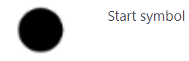

1. Join symbol

It is also known as synchronization bar that is used to combines two or more activities and flow where only one activity happens at a time.

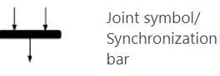

1. Fork symbol

Splits a one flow to two or more activities. Symbolize from a join to multiple arrow lines.

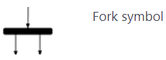

1. Decision symbol

It is a diamond shape which is used if there requires a decision to more from next activity then it use to get two activities.

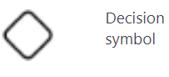

1. Note symbol

Note symbol is used for to get more information from diagram note for clearly and way to guide.

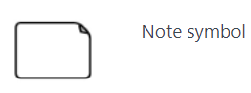

1. Option loop symbol

It is used for repeating process in system activity, also called loop symbol.

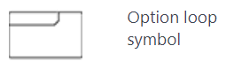

1. Action flow

It is used for communication one action to another action representation with an arrowed line.



1. Condition text

This is used in decision makes to show the message of what condition on activity flow.

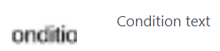

1. End symbol

In diagram at the last step of ending point activity process.

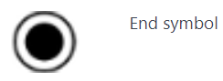

In this system have two activity user and admin. They have different action happens in activity diagram which is shown in below:

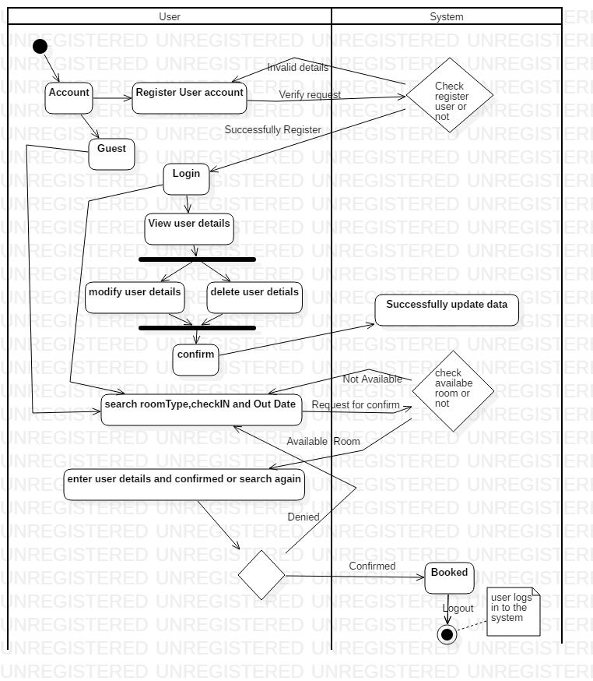

Figure 8:User Activity Diagram

In this activity diagram show that the user how to communicate with the system and database. It describes the user can register then login into system to system permission. After entering to the system user can able to do update, delete the user data and room booked with user requirement.

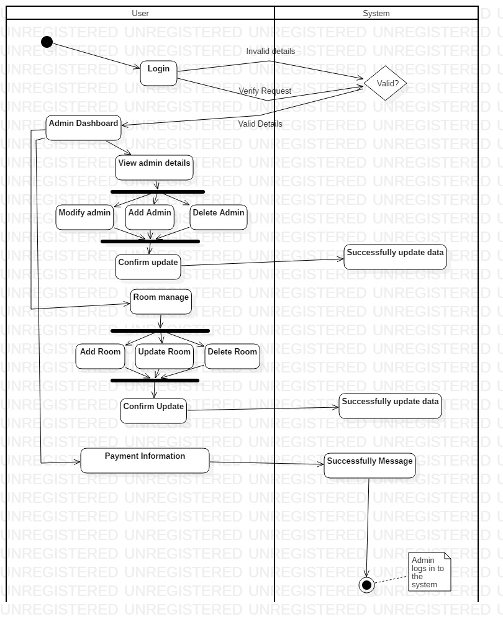

Figure 9:Admin Activity Diagram

In this activity diagram helps to describe the admin activities. After login admin can able to entered into the system, it will be able to apply CRUD operation on admin account, room manage as well as bill generate.

### b) sequence diagram

This diagram is known as dynamic modelling in UML and event diagram that describe interaction with classes and exchange of message over time. It focusses on lifelines or the process and objects. Specially, it displays the message exchanged between the function before the lifeline ends.

The purpose of this sequence diagram in this system is:

* It aids to show the user activities,
* It shows the admin activity on this system,
* It also aids to represent the UML use case details,
* Sequence diagram describe the planning and understanding the functionality from scenario.
* It identifies how object in an existing system currently interact in it.

In sequence diagram have some notation that are used in system diagram:

1. Lifeline

Lifeline represent the time which is extends downward. The vertical line shows the events that happen to an object that processes. In sequence diagram there are several drawn lifelines but not override each other.

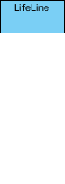

1. Activation Bars

This activation bars will represent the object what time is needed to complete this system task which is a thin rectangle shape in lifeline same place.

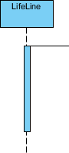

1. Actor symbol

Actor played the role of an entity that directly interact with the subject by exchanging signals data.



1. Comment

That comment also called note it gives the information which is very useful for system. It indicates the rectangle with a folding over in corner side which is linked with the object with a dashed line.



1. A Message Arrows

It indicates that the message sending and reception of a signal. The messages can flow left to right or right to left and return to the sender.

There is some symbol that helps to show the message arrows are:

1. Synchronous message

In synchronous stage for sender wait for the message from receiver message and carrying on with another message before return.



1. Asynchronous message

An asynchronous does not requires a response before sender messages.

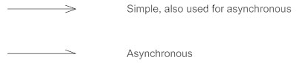

1. A return messages

A return message defines the communication between lifelines of an interaction. After the receiver were done process and return to the message caller to control overall process.

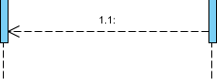

1. Found Message

It indicates some messages are send from endpoint to lifeline which is unknown.



1. Lost message

Some messages are sent to recipient arrows goes to an endpoint.



1. Sequence fragments

It represented as a box, on the top left corner there is an interaction operation which is apply a logical condition. It aids easier to create and maintain to get accurate diagram.

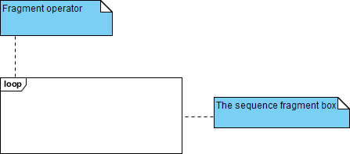

In sequence fragments have some operations which is used in their:

* Alt: Alternative multiple fragments is only the one condition is true then it will execute.
* Loop: Loop fragments must be executed in multiple times, its iteration process.

In this system have two sequence user and admin in below:

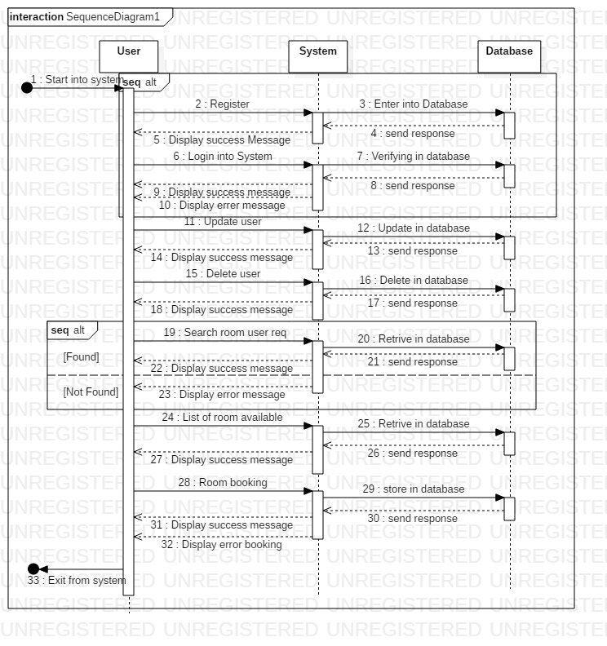

Figure 10:User Sequence Diagram

Sequence diagram is dynamic modelling showing the user activities. It will aids to clarify the user process from beginning to ending points.

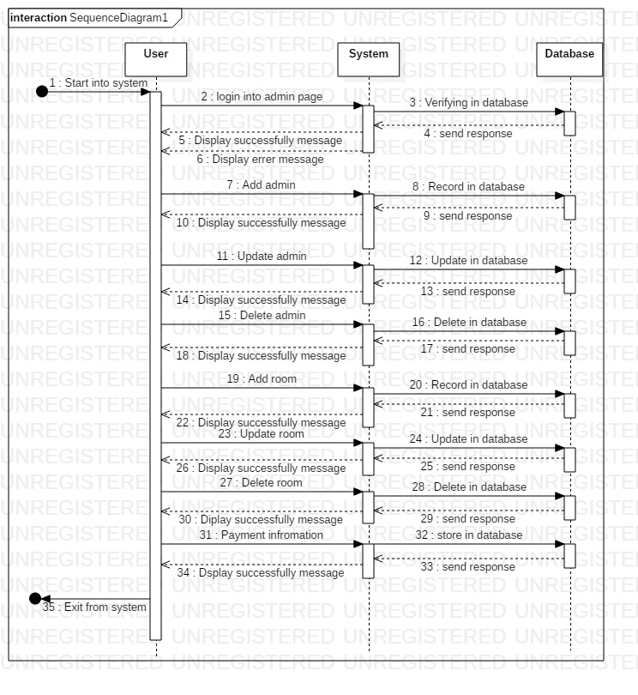

Figure 11:Admin Sequence Diagram

Admin sequence diagram helps to show the process or flow of guide to control this system. where admin can control user data and apply CRUD operation on it.

## 3.4 Database Model

A database model is khown as logical structure of database which defines the relationships and constraints. In system have also database model where we can able to store user information and accssed data. there are two entity relationship diagram data dictionary and, which is helps to clerly describe of this system.

### a) Entity Relationship Diagram

An entity relationship diagram is logical structure that show the relationship between entity and object that is used to stored data in a databse. This is a type of flowchart which is illustrates how it will relate to each other within this system.

The puropse of this diagram in system deign phase:

* ER Diagram helps to offers a visual presentation of the layout with effective design,
* In this system, it aids to increase flow of information and communication between user and system,
* ER Diagram is easy to use and understanding for non-technical client,
* It aids to analyst produce a good database structure modelling for repossess and store data in most actual manner.

This entity relationship diagram have using different notaion and relationship are:

1. **Cardinality**

It refers to maximum number time an example in one can related to another entity.

1. **Ordinality**

It refers to minimum number of time an example in one cane to associated to another entity.

1. **One to One**

Only one entity related to the same other entity.

1. **One to Many**

One entity can related to the multiple enitity.

1. **Many to One**

Multiple instance of an entity is related to one instance of an entity.

1. **Many to Many**

Multiple instance of an entity is related to the multiple instance of an entity.

In this project have ER Diagram of user, admin and system relation in below diagram:

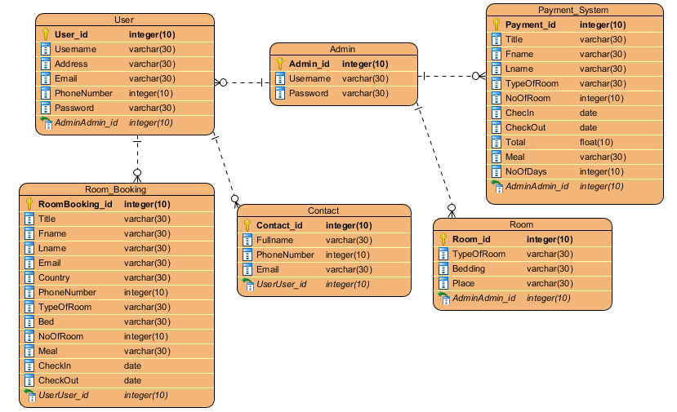

Figure 12:ER Diagram of system

This ER Diagram helps to show the relationship between user and system admin. It is easy to decribe with team members of this project. Using relationship notation help to connect one entity to another. In our system all activities are join each other with the strong relationship.

### b) Data Dictionary

A data dictionary is a collection of file or set of a data that store in database as metadata format. It is also known as blueprint as metadata that decribe what type of data is collect in database format. In this system have also database, which is help to store user data. In this system metadata is very important like:

* This is used to stored in user data for future infromation,
* In system, it helps to reduced paperwork for storing data,
* To maintain the compex and large amount of data in simple form,
* To improve the documentation and control, reduce data duplication in system information.

Metadata of this Hotel Booking Mnagament System is given below:

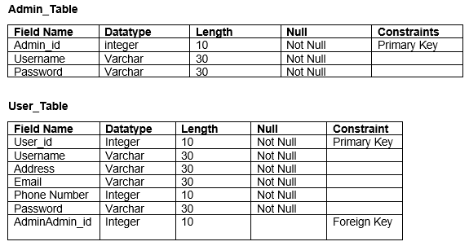

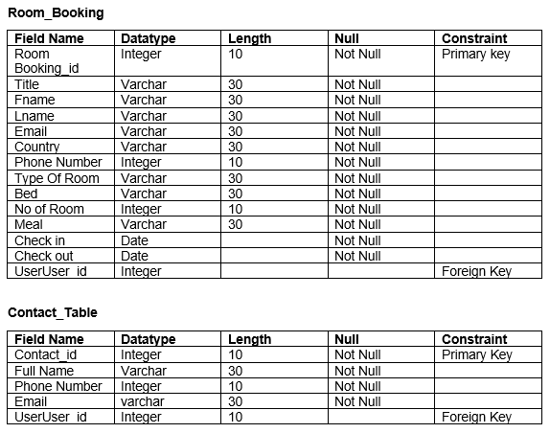

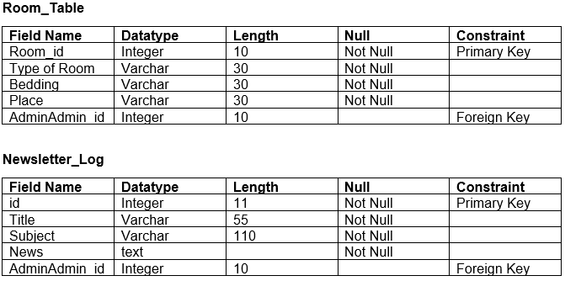

## 3.5 System Architecture

The system architectures are the process where the concepts that will be the support of the definite system are established and it helps to show the relationship between the system component.

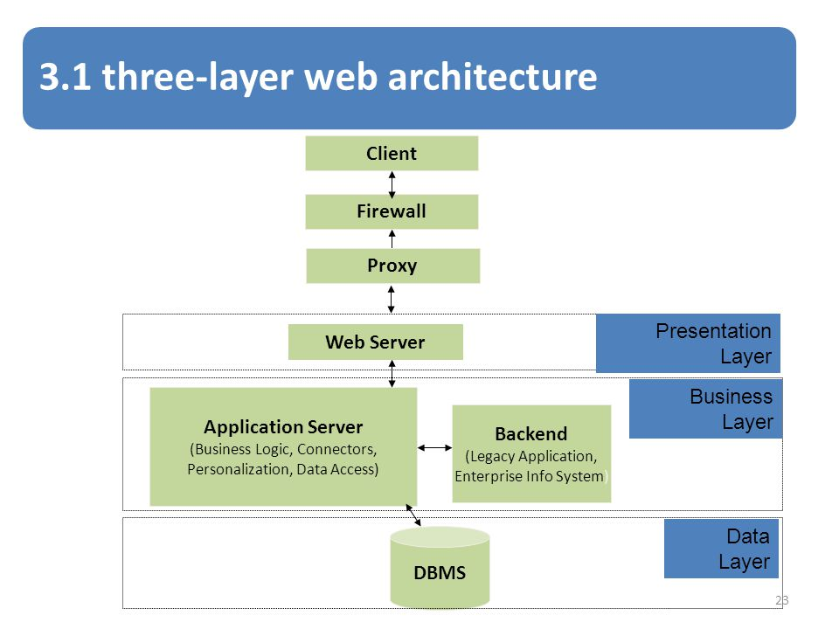

Figure 13:System Architecture

1. Presentation Layer: in this layer is user interface where user can view their system home page.
2. Business or logical layer: it describes the logical or coding part in system.
3. Data Link Layer: it describes the database where we can easily store data.

## 3.6 Prototype

Prototype is the process of creating a visual form which is known as blueprint or templates. It is the testing case after the model base design of the finished product. Prototyping is the most important phase in our hotel booking management system.

* It helps to create a project clear and fulfil user requirement,
* This is a test process so, we can get best result after developing the system,
* It helps to discuss what requirement are necessary for this system,
* It is the way of getting feedback and build a sufficiently complete product

There are some prototyping that are used to build a complete product have drawn below:

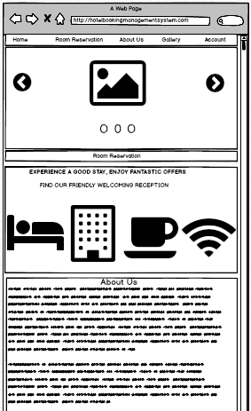

Figure 14:Prototype of Home Page

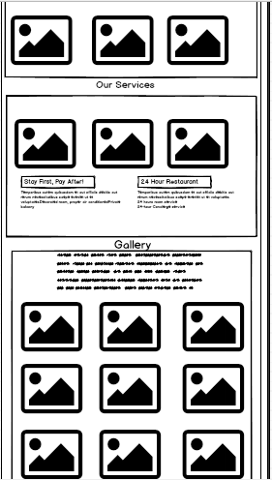

Figure 15:Prototype of Home Page

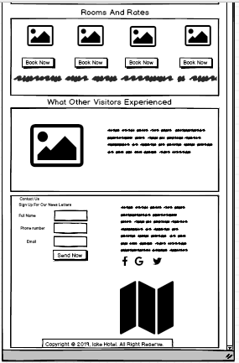

Figure 16:Prototype of Home Page

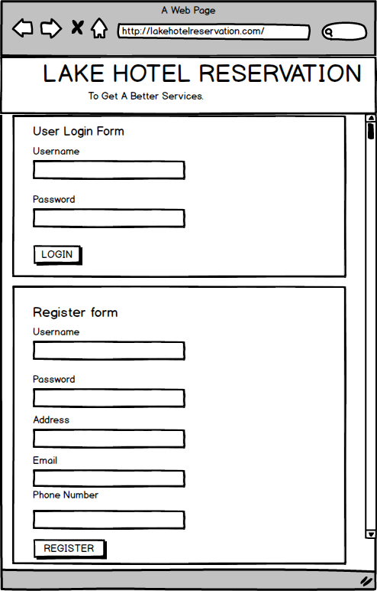

Figure 17:User Register and Login Page

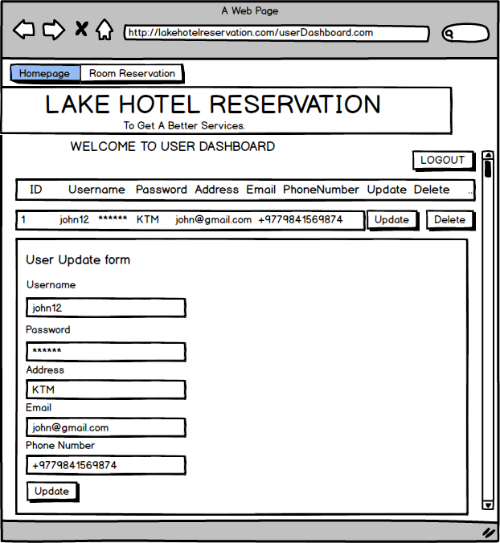

Figure 18:User Dashboard

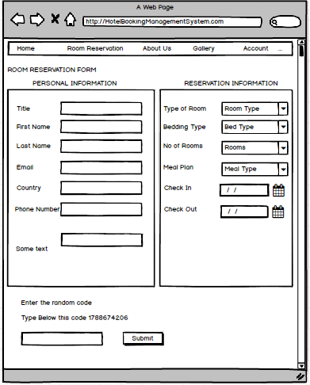

Figure 19:Prototype of Hotel Reservation

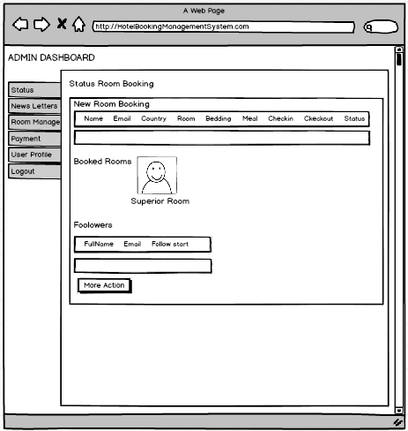

Figure 20: Admin Dashboard

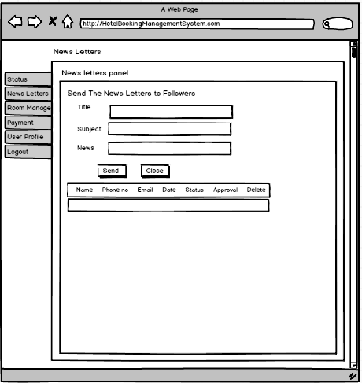

Figure 21:Admin Newsletters Manage

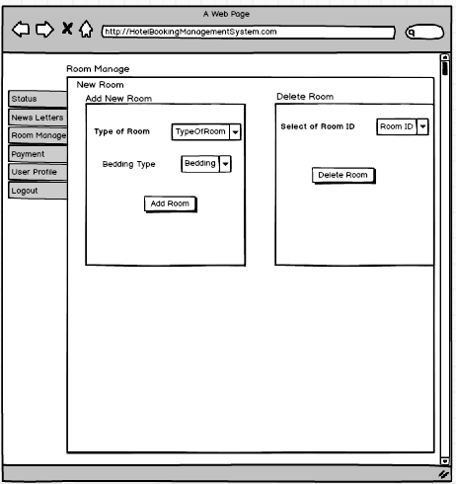

Figure 22:Admin Room Manage

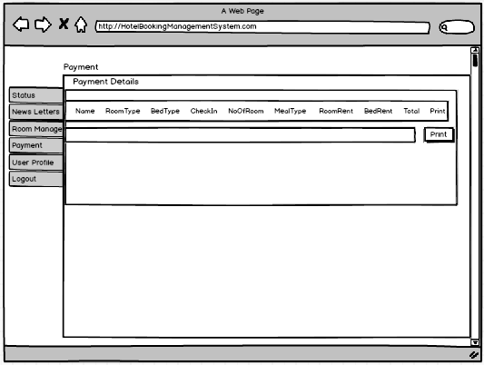

Figure 23:Admin Manage Payment Details

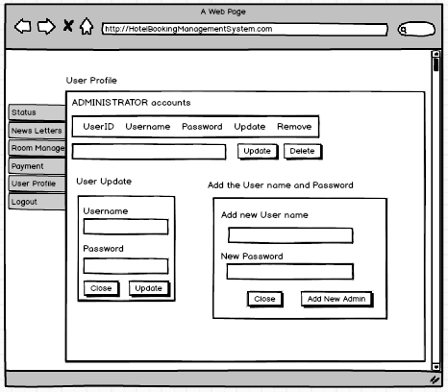

Figure 24:Admin Account CRUD Operation

## 3.7 Conclusion

At the last step of design phase, we are able to complete this phase. In first step we made class diagram and data flow diagram which is structural design. Then, next step we create behavioural diagram like activity diagram and sequence diagram. In database design we create data dictionary and Er diagram to show the relation between using StarUML and visual paradigm software. Then we create system architecture diagram. At last step, we able to create prototype of our system.

# Chapter-5

# 5. Testing

Testing is the process of evaluating the functionality of an application to check an activity whether the actual and expected results match or not and find out defects to ensure that the software is defects free for long lasting quality. It is the most important stage to completely check from end-to-end before submit this product.

In this project, testing is important that aids to point out defects in my project. There are some points are in below:

* While during the implementation stage sometimes programmer may make a mistake like incorrect coding of an algorithm in complex logical errors. That time testing is really required to point out the error in web-based application.
* It is important that aids to ensure that the quality of the product.
* It aids to find out whether our product is responsiveness or not in devices like smartphone, desktop and web browser like Google Chrome, Firefox etc.
* Sometimes, links are not working properly like clicking on a social icon that we make sure that go to the correct place.

In testing phase there are many types of testing available in below:

1. Unit testing
2. Blackbox testing
3. Whitebox testing
4. Acceptance testing
5. Integration testing
6. Beta testing
7. System testing
8. Functionality testing
9. Usability testing
10. Interface testing

In above there are many testing’s that are available. So, we are going to use only two types of testing are:

## 5.1 Unit Testing

This testing is done during the coding of an application. It is the first level of testing done before different types of testing. Unit testing is done to check every small details of an application separately by developers. It is also known as white box testing and code can be reused. It is easy to manage code with less cost than other type of testing.

In Unit Testing, we are going to testing that our coding is working properly or error free or not in below:

1. **User Register Test**

|  |  |  |  |  |  |
| --- | --- | --- | --- | --- | --- |
| **Test No.** | **Test Scenario** | **Test input data** | **Expected result** | **Actual result** | **Result** |
| **1** | User Register Test | Username: John123  Password: Wick12  Address: UAS  Email: john@gmail.com  Phone:9841986532 | User details should be registered in database. | User details successfully inserted without any problems. | Pass |

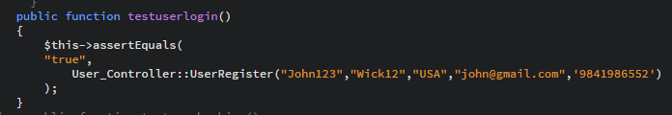

Figure 25:Testing Register User data.

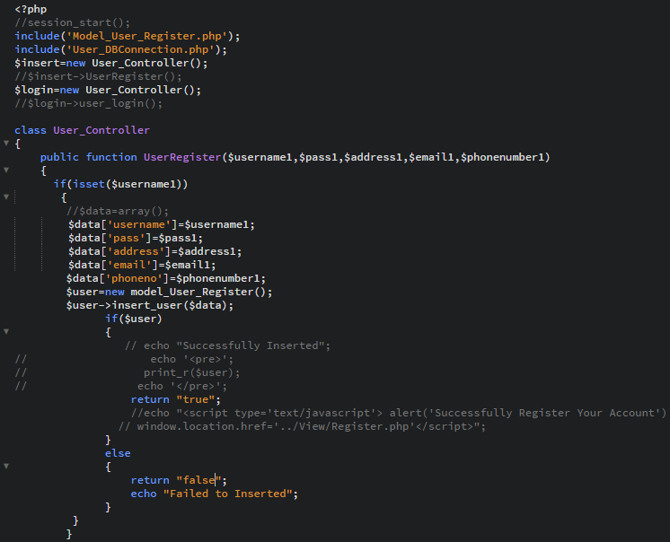

Figure 26:Testing Register user data

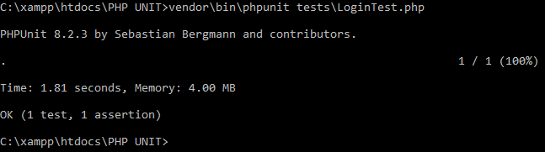

Figure 27:Result of User Register

1. **Login Test**

|  |  |  |  |  |  |
| --- | --- | --- | --- | --- | --- |
| **Test No.** | **Test Scenario** | **Test input data** | **Expected result** | **Actual result** | **Result** |
| **2** | User login testing | Username: John123  Password: Wick12 | User should be logged into user dashboard. | User successfully logged into system. | Pass |

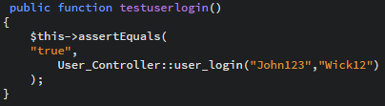

Figure 28:User Login Test

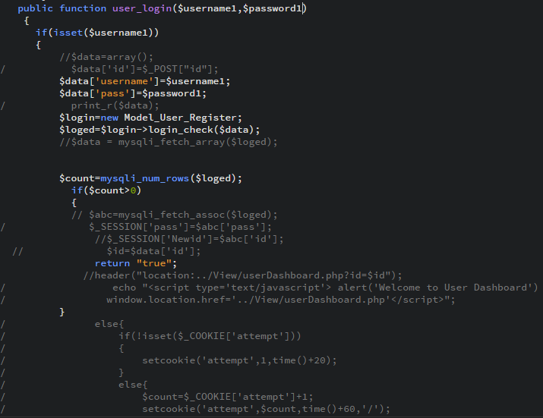

Figure 29:User Login Test.

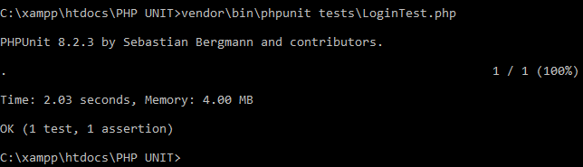

Figure 30:Result of User Login Case.

1. **User Room Reservation Test**

|  |  |  |  |  |  |
| --- | --- | --- | --- | --- | --- |
| **Test No.** | **Test Scenario** | **Test input data** | **Expected result** | **Actual result** | **Result** |
| **3** | User Booked room with specific requirement. | Title: Mr.  Name: John Wick  Email: john@gmail.com  Nationality: Nepalese  Country: Nepal  Phone:9841236591  TypeofRoom: Superior Room  Bed Type: Double  NoofRoom:2  Meal: Room Only  Checkin:03/07/2019  Checkout:05/07/2019 | Room booking details should be stored in database without any error. | Successfully all data stored in database without any problem. | Pass |

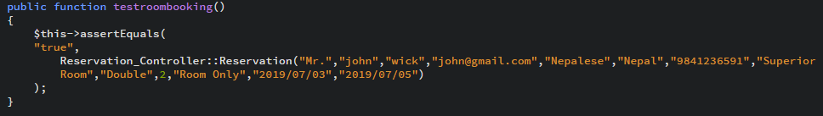

Figure 31:Testing of Room Reservation System.

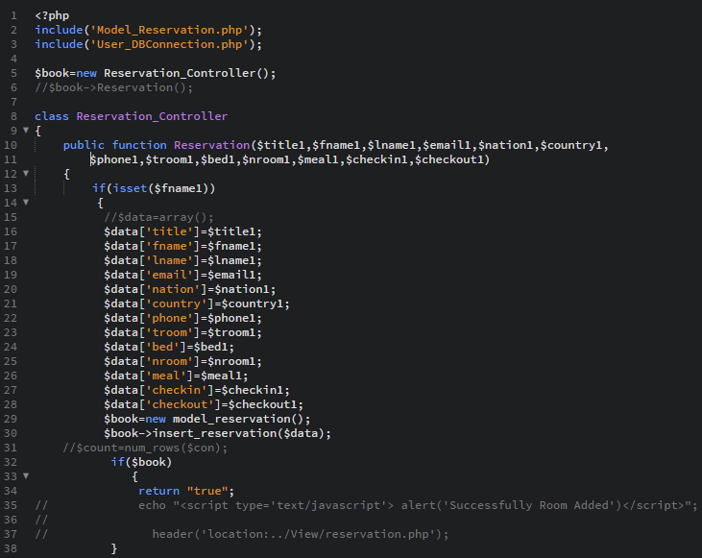

Figure 32:Testing of Room Reservation System.

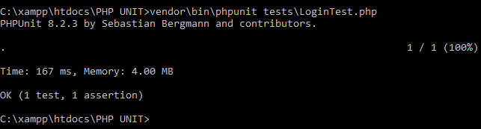

Figure 33:Result of Room Reservation System.

1. **Newsletter Test**

|  |  |  |  |  |  |
| --- | --- | --- | --- | --- | --- |
| **Test No.** | **Test Scenario** | **Test Input Data** | **Expected Result** | **Actual Result** | **Result** |
| **4.** | User have options to subscribe their newsletter. | Fullname: Selena Gomez  Phone: 9841756320  Email: [Selena@gmail.com](mailto:Selena@gmail.com) | User entry data should be store in database. | Successfully insert data in system database. | Pass |

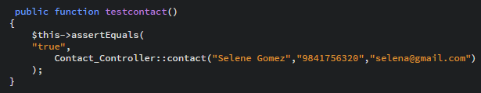

Figure 34:Newsletter Testing.

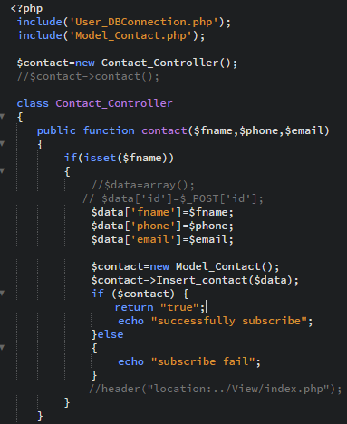

Figure 35:Newsletter Testing.

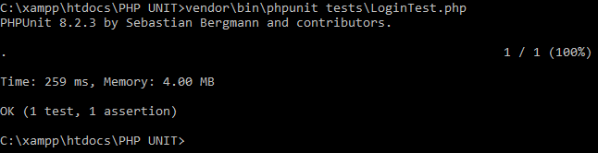

Figure 36:Newsletter Testing Result.

1. **Add New Admin Test**

|  |  |  |  |  |  |
| --- | --- | --- | --- | --- | --- |
| **Test No.** | **Test Scenario** | **Test Input Data** | **Expected Result** | **Actual Result** | **Result** |
| **5.** | New admin can insert in database or not. | Username: Peter  Password: Peter123 | The data of admin should be added in system. | New admin successfully inserted data. | Pass |

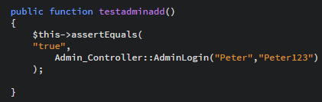

Figure 37:Testing of Add New Admin.

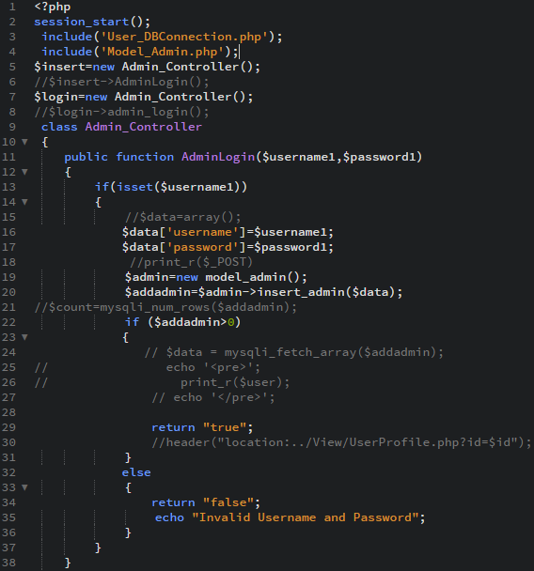

Figure 38:Testing of Add New Admin

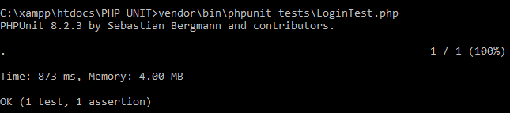

Figure 39:Added New Admin Result.

1. **Admin Login Test**

|  |  |  |  |  |  |
| --- | --- | --- | --- | --- | --- |
| **Test No.** | **Test Scenario** | **Test Input Data** | **Expected Result** | **Actual Result** | **Result** |
| **6.** | Admin must be able to login to system | Username: Admin  Password: Admin | Username and password matched then page it should be redirect into admin dashboard. | Successfully login in admin dashboard. | Pass |

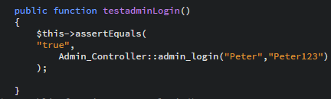

Figure 40:Admin Login Testing.

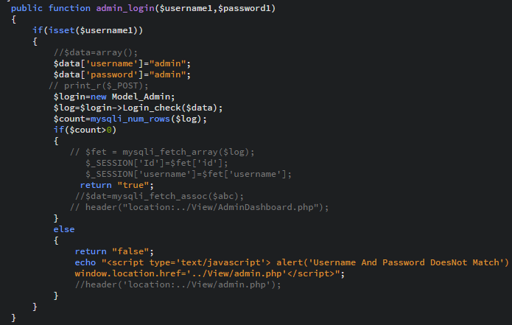

Figure 41:Admin Login Testing.

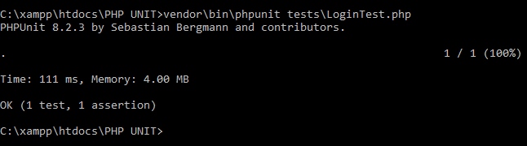

Figure 42:Login Admin Testing Result.

1. **Add Room Test**

|  |  |  |  |  |  |
| --- | --- | --- | --- | --- | --- |
| **Test No.** | **Test Scenario** | **Test Input Data** | **Expected Result** | **Actual Result** | **Result** |
| **7.** | Add new room by admin | RoomType: Superior Room  BedType: Double | Room and bed type should be inserted in system database. | Successfully stored New room. | Pass |

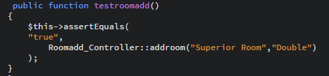

Figure 43:Admin Add New Room Testing.

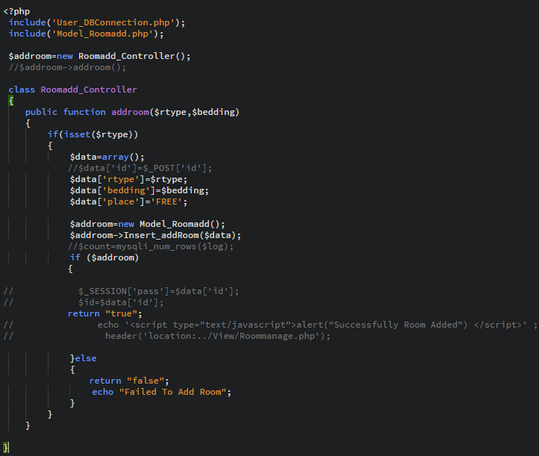

Figure 44:Admin Add New Room Testing.

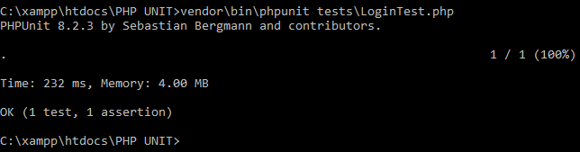

Figure 45:Admin Add New Room Result.

1. **Check Username in User Register**

|  |  |  |  |  |  |
| --- | --- | --- | --- | --- | --- |
| **Test No.** | **Test Scenario** | **Test Input Data** | **Expected Result** | **Actual Result** | **Result** |
| **8.** | Username checking | Username: John123  Password: Wick12  Address: UAS  Email: john@gmail.com  Phone:9841986532 | System must be show that the username already exists. | Success that username already exist and data doesn’t store in database. | Pass |



Figure 46:Testing of Re-submit username.



Figure 47:Testing of Re-submit username.

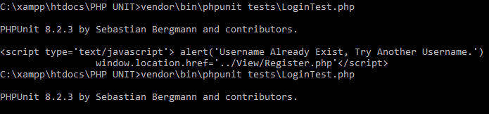

Figure 48:Re-submit Username Result.

## 5.3 Blackbox Testing

This testing is a method of software testing that defines the functionality of software application based on their description. It is also known as behavioural testing, which is tested all the functionality without known anything of internal structure, design and implementation and only observed entirely by what inputs are going and what outputs are coming. This testing can be applied every level of software testing stage.

In this stage, we are going to testing this product functionality with expected results.

**1) User Registration Test**

**Pre-Condition:** User must register before entering into the system.

|  |  |  |  |  |  |
| --- | --- | --- | --- | --- | --- |
| **Test No.** | **Test Scenario** | **Test input data** | **Expected result** | **Actual result** | **Result** |
| **1** | Check user registration properly working or not. | Username: Pradipdkl  Password: Pradip  Address: Dhapashi  Email: pradipdkl@gmail.com  Phone:9779813398480 | The user data should be registered into database and get username and password. | Successfully register user account and able to accessed with the system. | Pass |

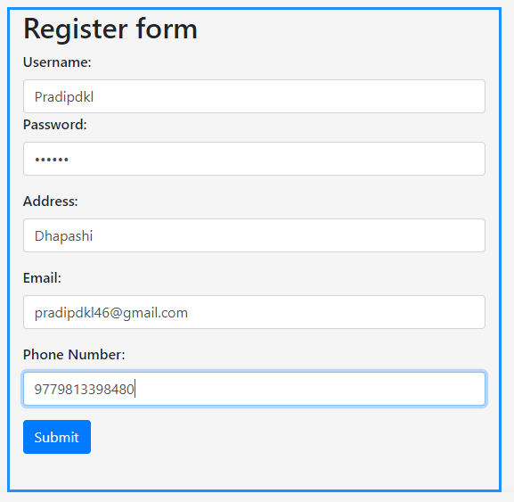

Figure 49:User Register data.

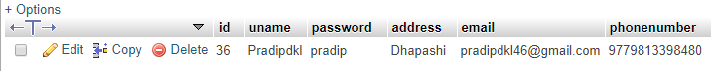

Figure 50:User Register Database.

**2. User Login Test**

**Pre-Condition:** User must be login before accessed into the system dashboard.

|  |  |  |  |  |  |
| --- | --- | --- | --- | --- | --- |
| **Test No.** | **Test Scenario** | **Test Input Data** | **Expected Result** | **Actual Result** | **Result** |
| **2.** | Check user can able to login into system or not. | Username: Pradipdkl  Password: Pradip | User should be login into system dashboard. | User successfully accessed into the system dashboard. | Pass |

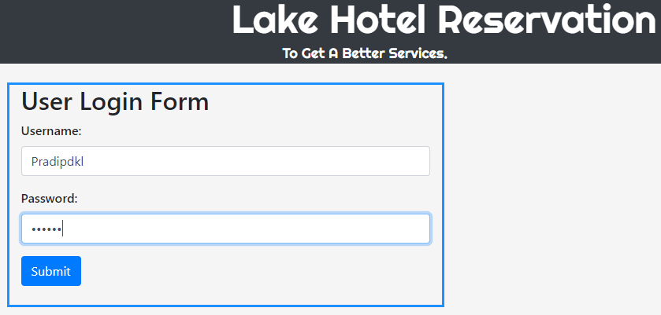

Figure 51:User Login Form



Figure 52:User Login Database

**3.User Data Update**

**Pre-Condition**: User must be able edit their user details.

|  |  |  |  |  |  |
| --- | --- | --- | --- | --- | --- |
| **Test No.** | **Test Scenario** | **Test Input Data** | **Expected Result** | **Actual Result** | **Result** |
| **3.** | To check if the user data update is working or not. | Username: Pradip1234  Password: Pradip  Address: Dhapashi  Email: pradipdkl@gmail.com  Phone:9779843936666 | User edit data must be changed and insert into database. | User successfully updated their data. | Pass |

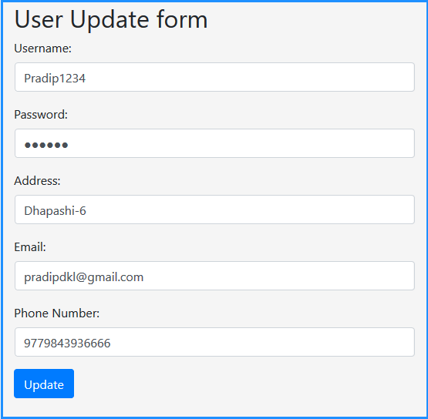

Figure 53:User Update Form

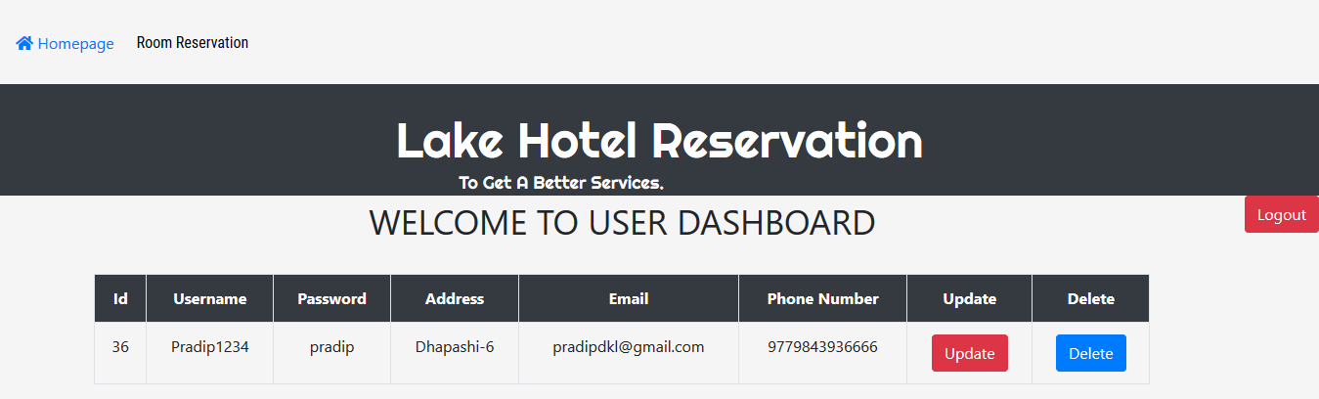

Figure 54:User Update Dashboard.



Figure 55:User Update Database

**4. User Reservation Room Test**

**Pre-Condition:** User must be able to book room with user requirement.

|  |  |  |  |  |  |
| --- | --- | --- | --- | --- | --- |
| **Test No.** | **Test Scenario** | **Test Input Data** | **Expected Result** | **Actual Result** | **Result** |
| **4.** | To check if the user booked room is working or not. | Title: Mr.  Name: Peter McKinnon  Email: peter@gmail.com  Nationality: Non-Nepalese  Country: Canada  Phone:9779874563210  TypeofRoom: Superior Room  Bed Type: Double  NoofRoom:1  Meal: Half Board  Checkin:02/07/2019  Checkout:07/07/2019 | All the entering data must be stored in database and book hotel room. | Successfully reserved their room with specific user requirement. | Pass |

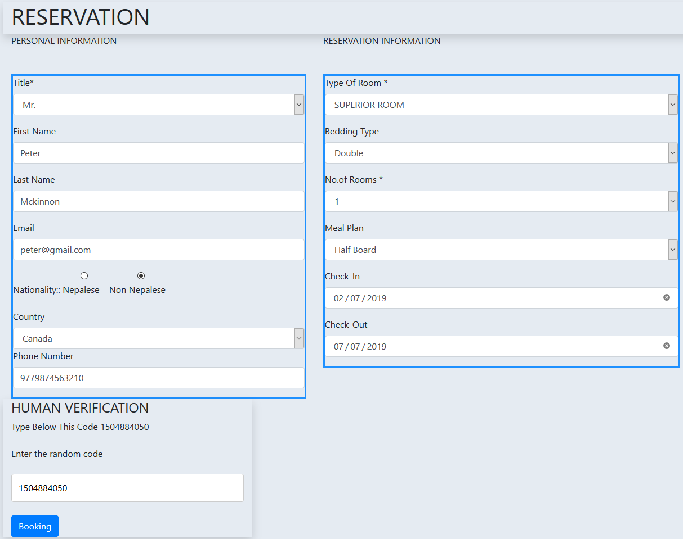

Figure 56:Room Reservation System.

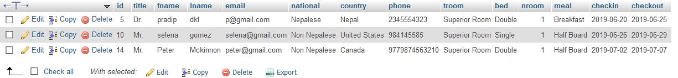

Figure 57:Room Reservation Database.

**5. Admin Login Test**

**Pre-Condition:** Admin must be able to login before accessed into the admin panel.

|  |  |  |  |  |  |
| --- | --- | --- | --- | --- | --- |
| **Test No.** | **Test Scenario** | **Test Input Data** | **Expected Result** | **Actual Result** | **Result** |
| **5.** | Check if admin account access into system or not | Username: admin  Password: admin | Admin can able to enter into admin dashboard. | Successfully login and able to accessed into system. | Pass |

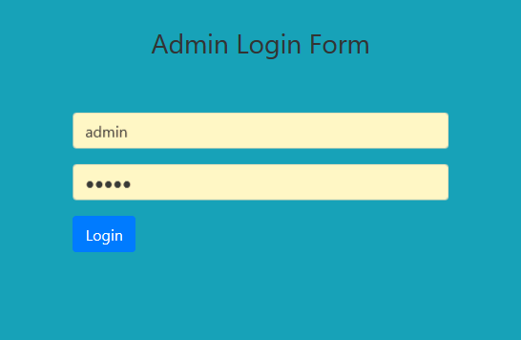

Figure 58:Admin Login Form

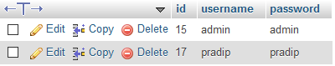

Figure 59:Admin Login Database

**6.Newsletter Test**

**Pre-Condition:** User have option to subscribe their newsletter.

|  |  |  |  |  |  |
| --- | --- | --- | --- | --- | --- |
| **Test No.** | **Test Scenario** | **Test Input Data** | **Expected Result** | **Actual Result** | **Result** |
| **6.** | User subscribe newsletter inserted working properly or not. | Fullname: Pradip Dkl  Phone: 9843936666  Email: Pradip@gmail.com | User data should be insert into database for to get notification. | Successfully user data insert in database. | Pass |

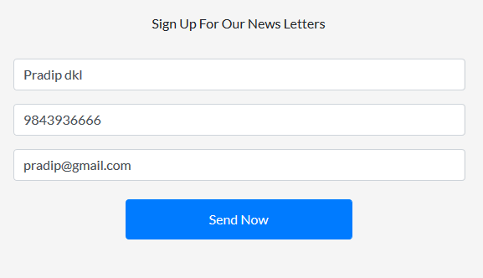

Figure 60:News Letter Form



Figure 61:Newsletter Database

**7. Remove Newsletter Test**

**Pre-Condition:** Only admin have permission to delete their data.

|  |  |  |  |  |  |
| --- | --- | --- | --- | --- | --- |
| **Test No.** | **Test Scenario** | **Test Input Data** | **Expected Result** | **Actual Result** | **Result** |
| **7.** | To check that newsletter data delete or not. | Fullname: Pradip  Phone:9876541230  Email: p@gmail.com | Admin should be deleted newsletter data form database. | Successfully admin can be able to removed. | Pass |

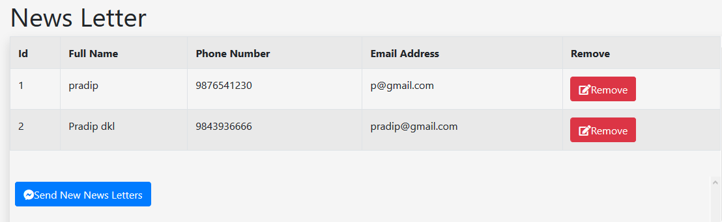

Figure 62:Newsletter Dashboard.



**8.Send Letter Test**

**Pre-Condition:** Admin should be sent message to user to get information.

|  |  |  |  |  |  |
| --- | --- | --- | --- | --- | --- |
| **Test No.** | **Test Scenario** | **Test Input Data** | **Expected Result** | **Actual Result** | **Result** |
| **8.** | To check that message sent to user or not. | Title: Reservation  Subject: Reservation Successfully.  News: Successfully Room Booking | Admin should be deleted newsletter data form database. | Successfully admin can be able to removed. | Pass |

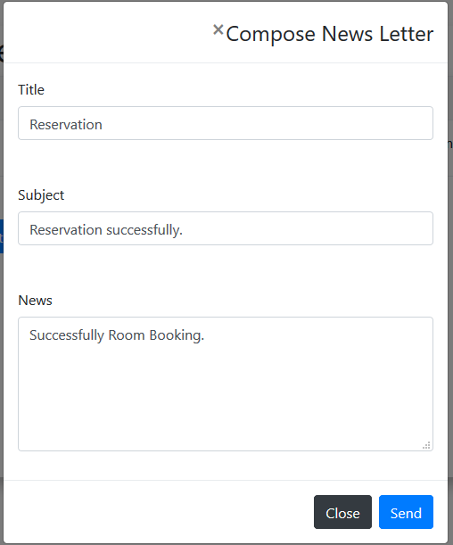

Figure 63:Compose Newsletter



Figure 64:Newsletter in Database

**9. Add Room Test**

**Pre-Condition:** Admin should be able to add room type and bed type.

|  |  |  |  |  |  |
| --- | --- | --- | --- | --- | --- |
| **Test No.** | **Test Scenario** | **Test Input Data** | **Expected Result** | **Actual Result** | **Result** |
| **9.** | To check if admin can able to adding or not. | RoomType: Superior Room  BedType: Quad | Admin should be added room and bed type in database. | Successfully admin can able to insert room and bed. | Pass |

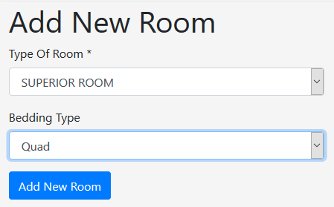

Figure 65:Add New Room



Figure 66:Adding New Room in Database.

**10.Delete Room Test**

**Pre-Condition:** Admin should be able to delete room type and bed type.

|  |  |  |  |  |  |
| --- | --- | --- | --- | --- | --- |
| **Test No.** | **Test Scenario** | **Test Input Data** | **Excepted Result** | **Actual Result** | **Result** |
| **10.** | To check if admin can able to delete their room details. | RoomType: Superior Room  BedType: Single | Admin should be deleted room and bedding type from database. | Successfully admin can able to delete room details. | Pass |

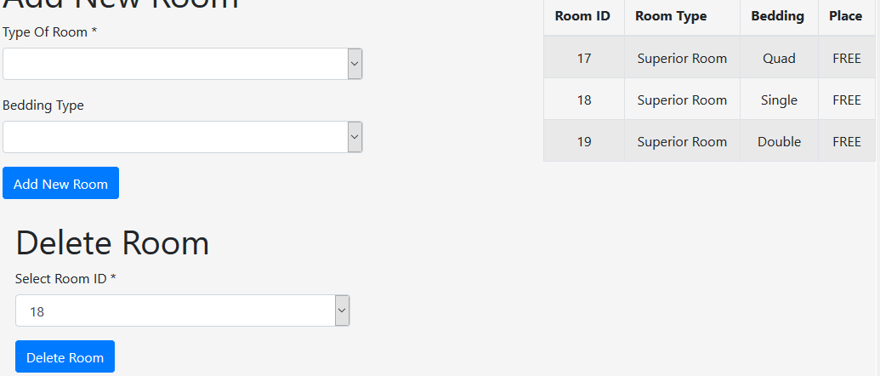

Figure 67:Delete Room Dashboard.

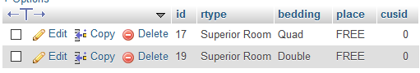

Figure 68:Delete Room in Database

**11. Add New Admin Test**

**Pre-Condition:** Admin have permission to add new admin account.

|  |  |  |  |  |  |
| --- | --- | --- | --- | --- | --- |
| **Test No.** | **Test Scenario** | **Test Input Data** | **Expected Result** | **Actual result** | **Result** |
| **11.** | Check if admin add new admin user or not. | Username: John@John  Password: John@Jhon | Admin should be added new admin account in database. | Successfully added new admin account in database. | Pass |

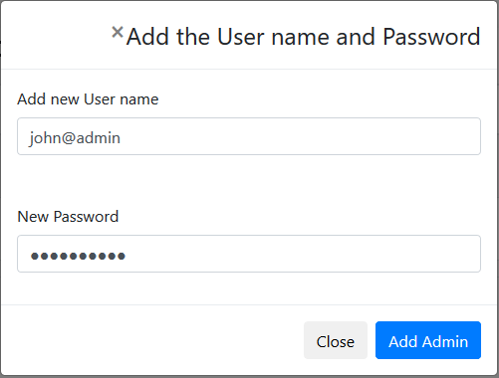

Figure 69:Add New admin Form

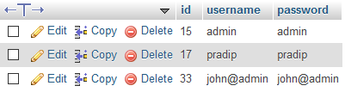

Figure 70:Add New Admin in Database.

**12. Delete Admin Account Test**

**Pre-Condition:** Admin have permission to delete their account.

|  |  |  |  |  |  |
| --- | --- | --- | --- | --- | --- |
| **Test No.** | **Test Scenario** | **Test Input Data** | **Expected Result** | **Actual Result** | **Result** |
| **12.** | To check if admin account able to delete or not | Username: Pradip  Password: Pradip | Admin should be deleted their admin account from database. | Successfully deleted admin account from database. | Pass |

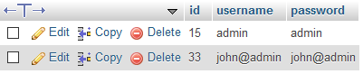

Figure 71:Delete Admin from Database.

# Chapter-6

## 6.1 Risk Management

Risk management is the process of point out the risk or what negative events in system. In our project there are lots of things that might prevent our goals. In any project risk are random thing. So, risk management system that aids to reduced threats then make this web application errorless and it helps to manage the risk.

While developing this project I face some issues and I able to solved with the help of likelihood and consequence table that described in below:

**Likelihood Risk Value**

|  |  |
| --- | --- |
| **Likelihood** | **Value** |
| Low | 1 |
| Medium | 2 |
| High | 3 |

**Consequences Risk Value**

|  |  |
| --- | --- |
| **Consequences** | **Value** |
| Very Low | 1 |
| Low | 2 |
| Medium | 3 |
| High | 4 |
| Very High | 5 |

**Impact= likelihood * consequence**

Risk Management Table describe in below:

|  |  |  |  |  |
| --- | --- | --- | --- | --- |
| **Risk** | **Likelihood** | **Consequence** | **Impact** | **Solution** |
| **Risk in Data Loss** | 2 | 4 | 8 | Sometime data were lost. Using Dailey backup to reduce data loss problem. |
| **Time Risk** | 1 | 3 | 3 | Project must be complete in appropriate time planning. |
| **Performance Risk** | 2 | 3 | 6 | Using high memory and maintain coding part aids increase good performance. |
| **Bad Design** | 2 | 4 | 8 | For create unique and attractive design, needed training about it. |

## 6.2 Configuration Management

A configuration management system is used to keep track hardware, software and information of the system. Basically, it is used to keep data secure and manageable form. In my project there are lots of folder that are linked to the project like analysis, design, implementation, proposal and testing in hotel booking management system.

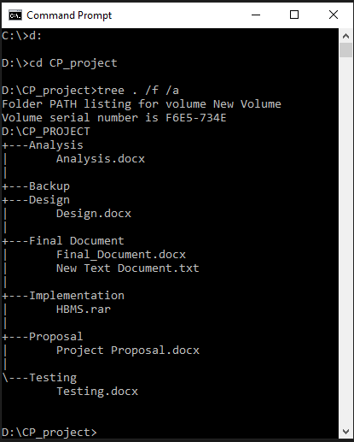

Figure 72:Tree for Configuration of Files

## 6.3 Project issues

While doing this project, I was faced some problems like check in and out date does not work, sometimes div and CSS not working properly like color change in different browser and image size resolution problems. In implementation stage some requirement was changed then I was started from beginning.

## 6.4 Limitation of project

In Hotel Booking Management System is not advance website. There are some limitations/demerits are listed below:

* This website is not advance so, whether room is available or none is not working properly,
* Search button is not available for questing,
* In this system user cannot be able to add, update or delete about hotel information,
* We do not have large server so that it is not faster and it takes some time to loading pages,
* For new user this web application will be tiny complexity.

## 6.5 Future Work

After all the task complete then, we need to find out what features we will need to be added in future in our system. Still some features are not working properly like room booking through online payment. So, there are some future work are listed below:

* In future we will be improved room booking problem payment through online system from world-wide banking transaction system,
* Advance room booking system but money will not be refunded.
* Now this website is focuses on desktop and mobile browser only but in future development, android application for Hotel Booking Management System,
* User does not need to login for booking room but in future work need to be login first before room booking in system and have options to edit as well as delete option in booking system.
* User have uploaded their profile image will be adding soon in user dashboard.

# Chapter-7

# 7.1 Conclusion

At the last step, all stages are like analysis, design, implementation and testing are successfully done. This Hotel Booking Management System is for reservation of hotel room to get user satisfaction about that website. For this project I am using Waterfall Model, that aids to clearly describe our system task with step by step. In first step is analysis which is for collect all requirements has been fulfilled. Then, design we created diagram for this project like class diagram, activity diagram as well as activity diagram. This diagram helps to describe flow of our system activities. Using Balsamiq Mock-up software we created prototype for our paces interface. Next step we were done implementation or coding then we executed. After implementation phase were done then testing was performed to find out whether our project is run without any issue or not using Unit Testing as well as Black Bok Testing. Finally, all requirement was fulfilled and successfully complete.